# **CTF Topic: Site Bleacher**

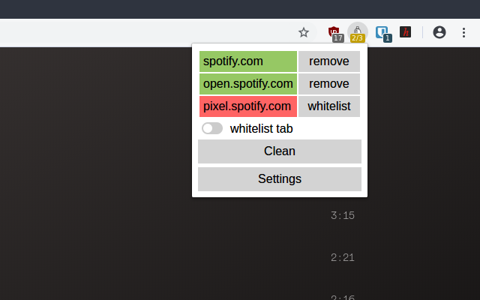

# **Introduction**

Site Bleacher is a website security scanner used to automatically identify security vulnerabilities in web applications. It scans for common vulnerabilities such as XSS, SQL injection, CSRF, insecure configuration, and more.



# **Tools and requirements**

Site Bleacher

# **Scenario**

You are a user who values privacy and wants to ensure that the websites you visit are free from unnecessary trackers and ads. Your task is to use Site Bleacher to analyze a specific website, identify elements that can be removed for a cleaner browsing experience, and improve your privacy.



# **Process to Follow while Performing CTF**

Step 1: Access the Altoro Mutual website in your browser: [**https://altoro.testfire.net/**](https://altoro.testfire.net/)

Step 2: Use Site Bleacher to perform a comprehensive security scan of the website: [**https://chromewebstore.google.com/search/Site%20Bleacher**](https://chromewebstore.google.com/search/Site%20Bleacher)

Step 3: Review the scan results to identify vulnerabilities such as XSS, SQL injection, CSRF, and others.

Step 4: Document your findings and prepare answers for the flags based on the vulnerabilities discovered.

# **Let's Begin The Challenge**

# **Question**

**Flag 1:** What is the highest severity level vulnerability identified by Site Bleacher?

**Answer:** High (Example: XSS vulnerability)

**Flag 2:** How many total vulnerabilities were found in the scan?

**Answer:** 5

**Flag 3:** Name one specific endpoint vulnerable to SQL injection.

**Answer:** /search.php

# **Hint**

Ensure to run a thorough scan using Site Bleacher, focusing on different aspects of the Altoro Mutual website. Document vulnerabilities with their severity levels and specific endpoints affected to answer the flags accurately.

This challenge focuses on using Site Bleacher to automate the process of identifying security vulnerabilities on a target website like Altoro Mutual.